Assignment 7
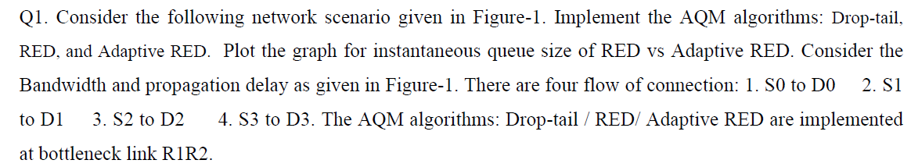
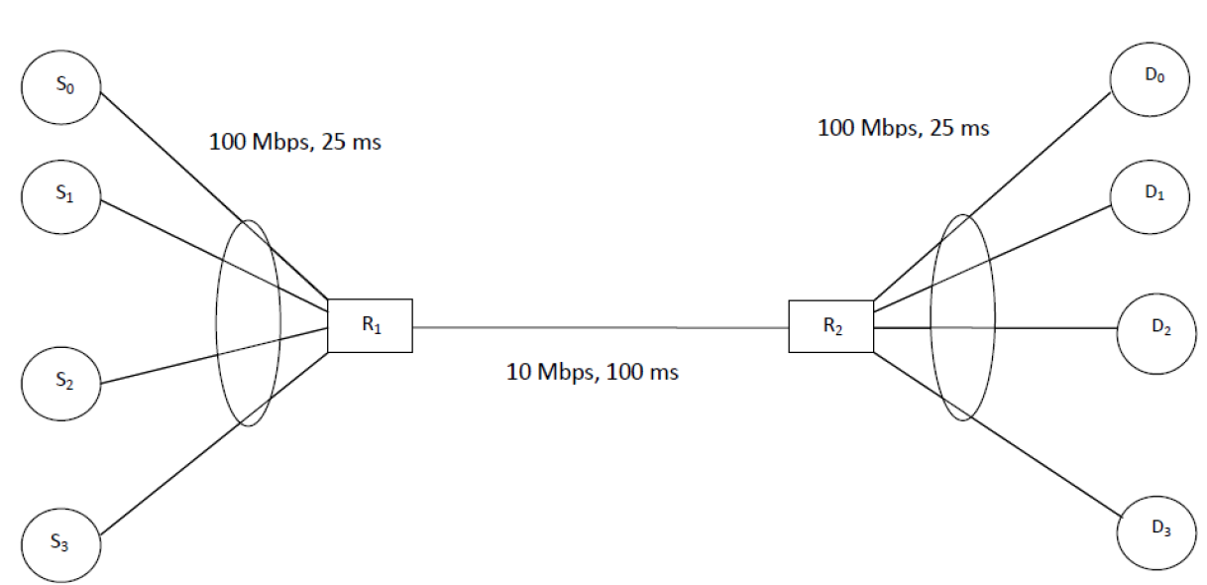
Code for Red:
set ns [new Simulator] set tracefile [open out.tr w] $ns trace-all $tracefile set namfile [open out.nam w] $ns namtrace-all $namfile
set s0 [$ns node] set s1 [$ns node] set s2 [$ns node] set s3 [$ns node]
set r1 [$ns node] set r2 [$ns node]
set d0 [$ns node] set d1 [$ns node] set d2 [$ns node] set d3 [$ns node]
$ns duplex-link $s0 $r1 100Mb 25ms DropTail
$ns duplex-link $s1 $r1 100Mb 25ms DropTail
$ns duplex-link $s2 $r1 100Mb 25ms DropTail
$ns duplex-link $s3 $r1 100Mb 25ms DropTail
$ns duplex-link-op $s0 $r1 orient right-down
$ns duplex-link-op $s1 $r1 orient right
$ns duplex-link-op $s2 $r1 orient right-up
$ns duplex-link-op $s3 $r1 orient right-up
$ns duplex-link $r2 $d0 100Mb 25ms DropTail
$ns duplex-link $r2 $d1 100Mb 25ms DropTail
$ns duplex-link $r2 $d2 100Mb 25ms DropTail
$ns duplex-link $r2 $d3 100Mb 25ms DropTail
$ns duplex-link-op $r2 $d0 orient right-up
$ns duplex-link-op $r2 $d1 orient right
$ns duplex-link-op $r2 $d2 orient right-down
$ns duplex-link-op $r2 $d3 orient right-down
#Queue/RED set gentle_ true #Queue/RED set adaptive_ true
set qtype RED
$ns duplex-link $r1 $r2 10Mb 100ms $qtype
$ns queue-limit $r1 $r2 50 set qfile [open queue.tr w] set qmon [$ns monitor-queue $r1 $r2 $qfile 0.1]
proc record {} { global ns qmon qfile set time [$ns now] set qsize [$qmon set pkts_] puts $qfile "$time $qsize" $ns at [expr $time + 0.1] "record" }
$ns duplex-link-op $r1 $r2 orient right $ns duplex-link-op $r1 $r2 queuePos 0.5
set tcp0 [new Agent/TCP] $ns attach-agent $s0 $tcp0 set sink0 [new Agent/TCPSink] $ns attach-agent $d0 $sink0 $ns connect $tcp0 $sink0
set tcp1 [new Agent/TCP] $ns attach-agent $s1 $tcp1 set sink1 [new Agent/TCPSink] $ns attach-agent $d1 $sink1 $ns connect $tcp1 $sink1
set tcp2 [new Agent/TCP] $ns attach-agent $s2 $tcp2 set sink2 [new Agent/TCPSink] $ns attach-agent $d2 $sink2 $ns connect $tcp2 $sink2
set tcp3 [new Agent/TCP] $ns attach-agent $s3 $tcp3 set sink3 [new Agent/TCPSink] $ns attach-agent $d3 $sink3 $ns connect $tcp3 $sink3
set ftp0 [new Application/FTP] $ftp0 attach-agent $tcp0
set ftp1 [new Application/FTP] $ftp1 attach-agent $tcp1
set ftp2 [new Application/FTP] $ftp2 attach-agent $tcp2
set ftp3 [new Application/FTP] $ftp3 attach-agent $tcp3
$ns at 0.1 "record"
$ns at 1.0 "$ftp0 start"
$ns at 1.0 "$ftp1 start"
$ns at 1.0 "$ftp2 start"
$ns at 1.0 "$ftp3 start"
$ns at 20.0 "$ftp0 stop"
$ns at 20.0 "$ftp1 stop"
$ns at 20.0 "$ftp2 stop" $ns at 20.0 "$ftp3 stop"
proc finish {} { global ns tracefile namfile qfile $ns flush-trace close $tracefile close $namfile close $qfile exec nam out.nam &
exit 0
}
$ns at 25.0 "finish" $ns run
Code for Adaptive Red: set ns [new Simulator] set tracefile [open out.tr w] $ns trace-all $tracefile set namfile [open out.nam w] $ns namtrace-all $namfile
set s0 [$ns node] set s1 [$ns node] set s2 [$ns node] set s3 [$ns node]
set r1 [$ns node] set r2 [$ns node]
set d0 [$ns node] set d1 [$ns node] set d2 [$ns node] set d3 [$ns node]
$ns duplex-link $s0 $r1 100Mb 25ms DropTail
$ns duplex-link $s1 $r1 100Mb 25ms DropTail
$ns duplex-link $s2 $r1 100Mb 25ms DropTail
$ns duplex-link $s3 $r1 100Mb 25ms DropTail
$ns duplex-link-op $s0 $r1 orient right-down
$ns duplex-link-op $s1 $r1 orient right
$ns duplex-link-op $s2 $r1 orient right-up
$ns duplex-link-op $s3 $r1 orient right-up
$ns duplex-link $r2 $d0 100Mb 25ms DropTail
$ns duplex-link $r2 $d1 100Mb 25ms DropTail
$ns duplex-link $r2 $d2 100Mb 25ms DropTail
$ns duplex-link $r2 $d3 100Mb 25ms DropTail $ns duplex-link-op $r2 $d0 orient right-up
$ns duplex-link-op $r2 $d1 orient right
$ns duplex-link-op $r2 $d2 orient right-down
$ns duplex-link-op $r2 $d3 orient right-down
Queue/RED set gentle_ true Queue/RED set adaptive_ true
set qtype RED
$ns duplex-link $r1 $r2 10Mb 100ms $qtype $ns queue-limit $r1 $r2 50 set qfile [open queue.tr w] set qmon [$ns monitor-queue $r1 $r2 $qfile 0.1]
proc record {} { global ns qmon qfile set time [$ns now] set qsize [$qmon set pkts_] puts $qfile "$time $qsize" $ns at [expr $time + 0.1] "record" }
$ns duplex-link-op $r1 $r2 orient right $ns duplex-link-op $r1 $r2 queuePos 0.5
set tcp0 [new Agent/TCP] $ns attach-agent $s0 $tcp0 set sink0 [new Agent/TCPSink] $ns attach-agent $d0 $sink0 $ns connect $tcp0 $sink0
set tcp1 [new Agent/TCP] $ns attach-agent $s1 $tcp1 set sink1 [new Agent/TCPSink] $ns attach-agent $d1 $sink1 $ns connect $tcp1 $sink1
set tcp2 [new Agent/TCP] $ns attach-agent $s2 $tcp2 set sink2 [new Agent/TCPSink] $ns attach-agent $d2 $sink2 $ns connect $tcp2 $sink2
set tcp3 [new Agent/TCP] $ns attach-agent $s3 $tcp3 set sink3 [new Agent/TCPSink] $ns attach-agent $d3 $sink3 $ns connect $tcp3 $sink3
set ftp0 [new Application/FTP] $ftp0 attach-agent $tcp0
set ftp1 [new Application/FTP] $ftp1 attach-agent $tcp1
set ftp2 [new Application/FTP] $ftp2 attach-agent $tcp2
set ftp3 [new Application/FTP] $ftp3 attach-agent $tcp3
$ns at 0.1 "record"
$ns at 1.0 "$ftp0 start"
$ns at 1.0 "$ftp1 start"
$ns at 1.0 "$ftp2 start"
$ns at 1.0 "$ftp3 start"
$ns at 20.0 "$ftp0 stop"
$ns at 20.0 "$ftp1 stop"
$ns at 20.0 "$ftp2 stop" $ns at 20.0 "$ftp3 stop"
proc finish {} { global ns tracefile namfile qfile $ns flush-trace close $tracefile close $namfile close $qfile exec nam out.nam &
exit 0
}
$ns at 25.0 "finish" $ns run
Code for DropTail: set ns [new Simulator] set tracefile [open out.tr w] $ns trace-all $tracefile set namfile [open out.nam w] $ns namtrace-all $namfile
set s0 [$ns node] set s1 [$ns node] set s2 [$ns node] set s3 [$ns node]
set r1 [$ns node] set r2 [$ns node]
set d0 [$ns node] set d1 [$ns node] set d2 [$ns node] set d3 [$ns node]
$ns duplex-link $s0 $r1 100Mb 25ms DropTail
$ns duplex-link $s1 $r1 100Mb 25ms DropTail
$ns duplex-link $s2 $r1 100Mb 25ms DropTail
$ns duplex-link $s3 $r1 100Mb 25ms DropTail
$ns duplex-link-op $s0 $r1 orient right-down
$ns duplex-link-op $s1 $r1 orient right
$ns duplex-link-op $s2 $r1 orient right-up
$ns duplex-link-op $s3 $r1 orient right-up
$ns duplex-link $r2 $d0 100Mb 25ms DropTail
$ns duplex-link $r2 $d1 100Mb 25ms DropTail
$ns duplex-link $r2 $d2 100Mb 25ms DropTail
$ns duplex-link $r2 $d3 100Mb 25ms DropTail
$ns duplex-link-op $r2 $d0 orient right-up
$ns duplex-link-op $r2 $d1 orient right
$ns duplex-link-op $r2 $d2 orient right-down $ns duplex-link-op $r2 $d3 orient right-down
set qtype DropTail
$ns duplex-link $r1 $r2 10Mb 100ms $qtype $ns queue-limit $r1 $r2 50 set qfile [open queue.tr w] set qmon [$ns monitor-queue $r1 $r2 $qfile 0.1]
proc record {} { global ns qmon qfile set time [$ns now] set qsize [$qmon set pkts_] puts $qfile "$time $qsize" $ns at [expr $time + 0.1] "record" }
$ns duplex-link-op $r1 $r2 orient right $ns duplex-link-op $r1 $r2 queuePos 0.5
set tcp0 [new Agent/TCP] $ns attach-agent $s0 $tcp0 set sink0 [new Agent/TCPSink] $ns attach-agent $d0 $sink0 $ns connect $tcp0 $sink0
set tcp1 [new Agent/TCP] $ns attach-agent $s1 $tcp1 set sink1 [new Agent/TCPSink] $ns attach-agent $d1 $sink1
$ns connect $tcp1 $sink1
set tcp2 [new Agent/TCP] $ns attach-agent $s2 $tcp2 set sink2 [new Agent/TCPSink] $ns attach-agent $d2 $sink2 $ns connect $tcp2 $sink2
set tcp3 [new Agent/TCP] $ns attach-agent $s3 $tcp3 set sink3 [new Agent/TCPSink] $ns attach-agent $d3 $sink3 $ns connect $tcp3 $sink3
set ftp0 [new Application/FTP] $ftp0 attach-agent $tcp0
set ftp1 [new Application/FTP] $ftp1 attach-agent $tcp1
set ftp2 [new Application/FTP] $ftp2 attach-agent $tcp2
set ftp3 [new Application/FTP] $ftp3 attach-agent $tcp3
$ns at 0.1 "record"
$ns at 1.0 "$ftp0 start"
$ns at 1.0 "$ftp1 start"
$ns at 1.0 "$ftp2 start"
$ns at 1.0 "$ftp3 start"
$ns at 20.0 "$ftp0 stop"
$ns at 20.0 "$ftp1 stop"
$ns at 20.0 "$ftp2 stop" $ns at 20.0 "$ftp3 stop"
proc finish {} { global ns tracefile namfile qfile $ns flush-trace close $tracefile close $namfile close $qfile exec nam out.nam &
exit 0
}
$ns at 25.0 "finish"
$ns run
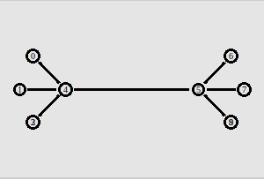
Graphs:
Queue_size:
DropTail:2696.64
Red: 2495.43
Adaptive Red: 2495.43
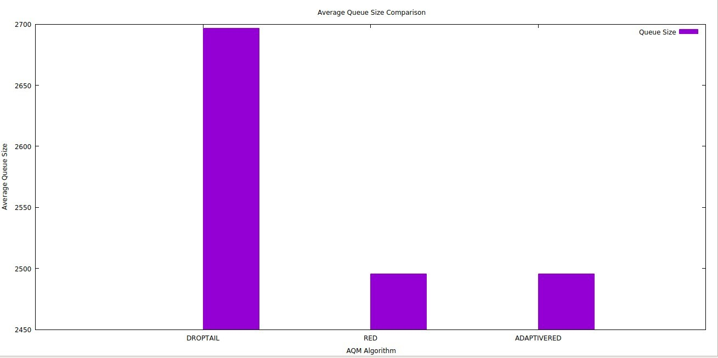
Throughput:
DropTail:5.99434
Red: 5.68275
Adaptive Red: 5.68275
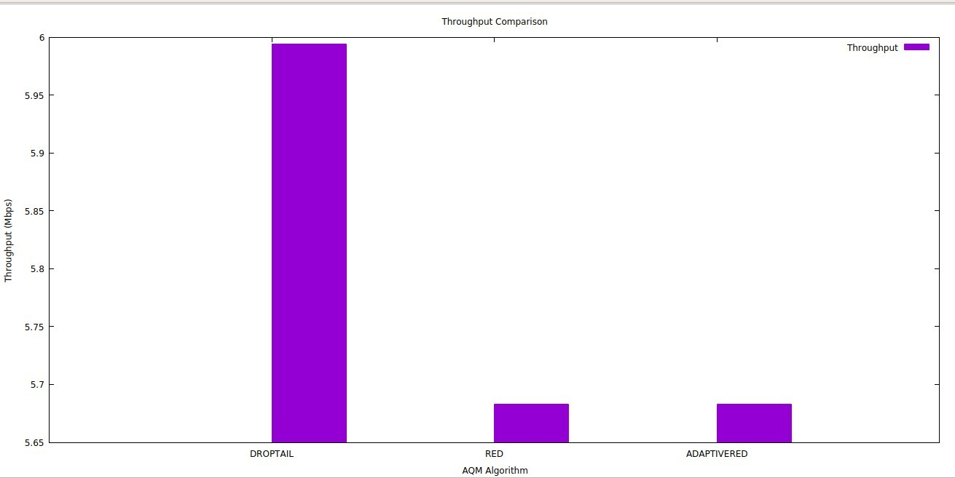
End to end delay:
DropTail:0.0160255
Red: 0.0268167
Adaptive Red: 0.0268167
